Zaroori Baat

Scan Classify Review Decide

1. Executive Summary
Build a human-in-the-loop agent that scans messages posted to an approved Slack channel, classifies and prioritizes them, and routes only relevant items to a reviewer. The reviewer sees the message, category, priority, confidence, and rationale, then decides whether to respond, dismiss, or escalate.
The project is a focused demo of agent orchestration, memory, tool calling, evaluation, and Harness engineering. It scans only an approved Slack channel and is not intended to read direct messages, private channels, or send unsupervised replies.

2. Problem Statement
Important messages are mixed with low-value noise in a Slack channel. Users need a way to:
• Scan new messages from the approved Slack channel.
• Classify them into agreed categories.
• Rank relevance and urgency.
• Present a concise review queue with explainable decisions.
• Keep a human responsible for the final response decision.

3. Goals and Non-Goals

Goals
• Demonstrate an end-to-end Slack-channel-to-decision workflow.
• Use Slack Events API for new channel messages and Slack Web API for a bounded history scan or backfill if feasibility is confirmed.
• Provide a mock-message fallback so the demo remains runnable.
• Use structured outputs, tool calls, persistent state, and traceable decisions.
• Measure classification quality, routing quality, latency, and human override behavior.

Non-Goals
• Reading direct messages, private channels, or any Slack channel outside the approved target channel and workspace authorization.
• Reading arbitrary Slack channels, workspaces, or desktop notifications outside the approved target channel and app scopes.
• Bypassing Slack workspace permissions, OAuth scopes, or platform policies.
• Fully autonomous responses.
• Production-grade multi-tenant security, billing, or 24/7 operations.

4. Feasibility Gate
The team should run this gate before committing to the Slack channel path.
Question | Evidence required | Decision
Can the team access a Slack workspace and install/configure an app for the target channel? | Workspace admin approval, app credentials, OAuth scopes, target channel ID, bot membership, event subscriptions, and request URL access | Required for Slack demo
Can new messages and bounded history from the target Slack channel be delivered to the service? | Successful Slack Events API delivery, signature validation, and a Slack Web API history scan for the target channel | Required
Can the demo be run within the six-day window? | Working vertical slice by the end of Day 2 | Required
Can the team show a compliant response flow? | Human approval before any outbound message | Required
Can the same workflow run without Slack app credentials? | Mock adapter | Required fallback

Feasibility conclusion rule
• Go: A Slack channel event is received and a bounded history scan completes by Day 2; the vertical slice works end to end.
• Conditional go: Slack channel access, event subscriptions, history scanning, or outbound messaging is unstable; demo classification and review using captured or mock messages, with the limitation stated clearly.
• No-go for Slack: No approved app credentials or target-channel access by Day 2. Use the same agent behind a mock adapter and present live Slack scanning as a future integration.
The project must not depend on unofficial Slack Web automation, personal-account scraping, channel exports outside approved APIs, or attempts to capture desktop notifications.

5. Proposed MVP Workflow
1. The service monitors the approved Slack channel for new messages through Slack Events API and can scan a bounded recent history window through Slack Web API or the mock adapter.
2. The ingestion service validates the event or history record, confirms the target channel ID, deduplicates the message, and stores the raw message with workspace, channel, thread, timestamp, and source identifiers.
3. The classifier assigns a category, relevance score, urgency, and confidence.
4. The router sends high-relevance messages to the review queue and suppresses or groups low-value noise.
5. The reviewer inspects the Slack message, channel or thread context, rationale, extracted entities, and suggested action.
6. The reviewer chooses Approve, Reject, Defer, or Escalate.
7. An approved response is either posted to the configured Slack channel or thread through the adapter or displayed as a demo action.
8. The decision and reviewer correction are stored for evaluation and future improvement.
Suggested initial categories:
• Action required
• Scheduling or logistics
• Important update
• Question
• Low priority
• Spam or irrelevant

6. Architecture
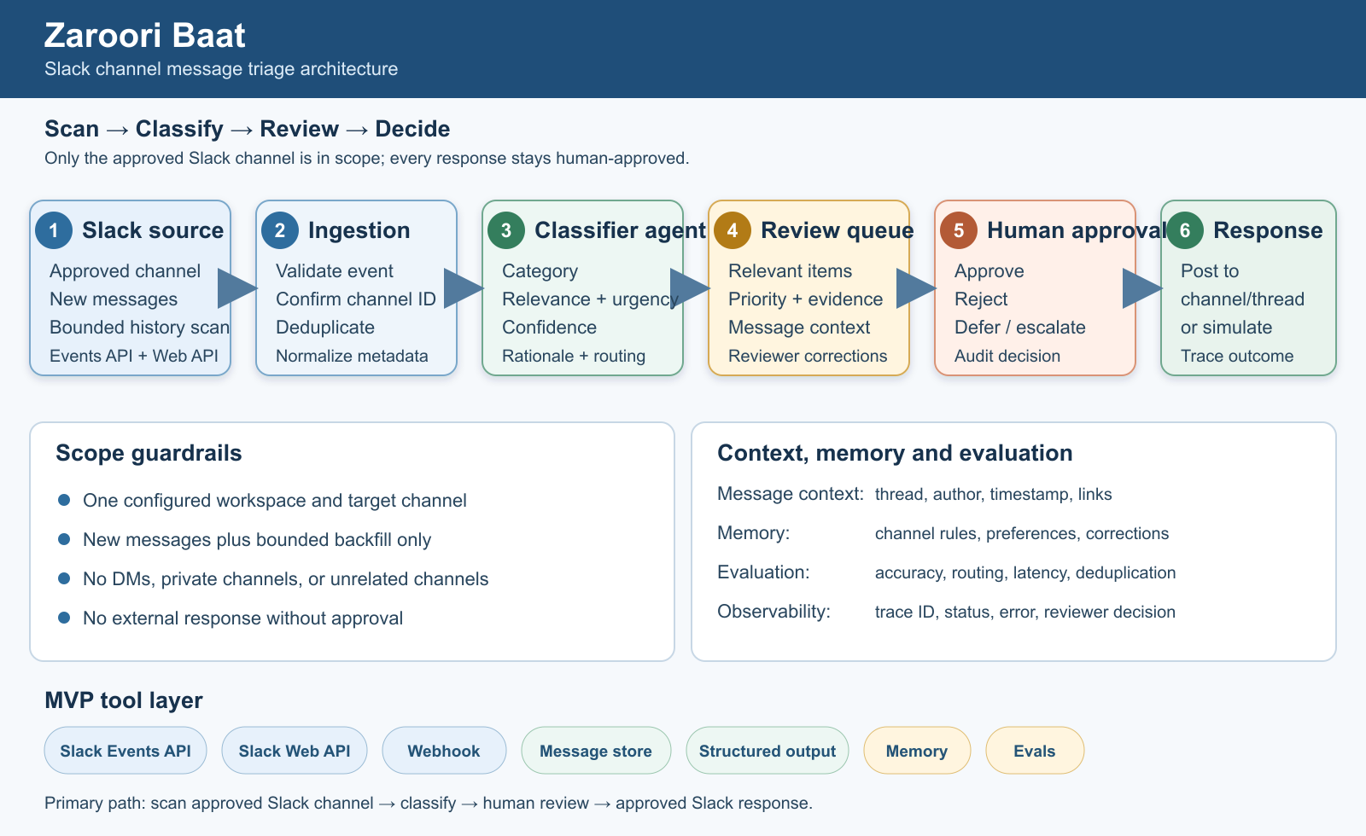

Core components
Component | Responsibility | MVP implementation
Channel adapter | Monitor the target Slack channel and normalize event or history messages | Slack Events API plus bounded Slack Web API history scan and mock adapter
Webhook service | Receive, authenticate, validate, and acknowledge events | Small API service
Message store | Persist raw and normalized messages | SQLite or managed document store
Classifier agent | Categorize, score, summarize, and extract entities | Structured JSON output
Router | Apply thresholds and route messages | Deterministic policy plus agent result
Review queue | Show pending decisions and status | Simple web UI
Human approval tool | Require explicit decision before response | Approve/reject/defer/escalate actions
Response adapter | Send approved response or simulate send | Slack channel or thread response plus mock implementation
Memory layer | Store preferences, corrections, and message context | Short-term state plus searchable summaries
Evals and tracing | Record inputs, outputs, tool calls, and scores | Trace store and repeatable dataset

7. Slack Integration Scope

Supported path
Use the official Slack Events API for new messages and Slack Web API for a bounded scan of the approved channel history, through a Slack app subject to workspace admin approval. The integration requires:
• A Slack app installed in the approved workspace, with the bot invited to the target channel.
• A bot token with only the required OAuth scopes for the target channel, history scan, and response posting.
• A signing secret, app credentials, and required permissions stored outside source control.
• Public HTTPS request URL or a tunnel for development.
• URL verification, request-signature validation, event validation, and channel-ID filtering.
• A clear inbound message schema containing workspace ID, channel ID, message timestamp, thread timestamp when present, author ID, text, and event type.

Important constraints
• Only messages from the approved target Slack channel are in scope; the bot must be installed in the workspace and invited to that channel.
• Direct messages, private channels, and other channels are out of scope unless explicitly approved and configured; access is limited to the approved channel, OAuth scopes, and event subscriptions.
• The app receives only events allowed by its OAuth scopes and event subscriptions, and outbound messages may be constrained by workspace permissions, channel membership, rate limits, and app scopes.
• Message content, consent, retention, and demo data must be handled responsibly.
• No secret or access token belongs in the repository, screenshots, or recorded demo.

Adapter contract
receive_event() -> NormalizedMessage
send_response(message_id, text) -> DeliveryResult
health_check() -> IntegrationStatus
The normalized message should retain workspace, channel, thread, author, timestamp, text, and event metadata. The agent should depend on this contract rather than directly on Slack SDK calls. This keeps the mock fallback inexpensive.

8. Agent Orchestration and Harness Engineering
Harness engineering is a first-class deliverable: the team is building the environment, tools, traces, guardrails, and feedback loops that make the agent observable and improvable.

Agent responsibilities
• Read one normalized Slack channel message at a time.
• Call tools for persistence, retrieval, queue updates, and approved responses.
• Return a strict schema, for example:
{
"category": "action_required",
"relevance": 0.91,
"urgency": "high",
"confidence": 0.87,
"summary": "Customer needs confirmation before Friday",
"suggested_action": "Review and respond",
"requires_human_approval": true
}

Guardrails
• Never send an outbound response without an explicit human approval event.
• Reject malformed or untrusted tool arguments.
• Use idempotency keys so webhook retries do not create duplicate work.
• Keep the Slack message, workspace and channel identifiers, model output, tool calls, and reviewer decision traceable by one message ID.
• Apply confidence thresholds; route uncertain messages to review rather than silently dropping them.
• Redact secrets and minimize personally identifiable information in logs.
• Fail closed when the integration or response tool is unavailable.

Observability
Every demo run should expose:
• Input Slack message, channel, thread, and source.
• Model classification and confidence.
• Tools called and their arguments.
• Routing decision and threshold used.
• Human decision and any correction.
• Final response status.
• Latency and error state.

9. Memory Design
Memory should improve decisions without becoming an uncontrolled archive.

Short-term memory
• Current Slack message, workspace and channel identifiers, thread identifier, recent normalized context, and pending review state.
• Used to avoid losing context during one workflow.

Long-term memory
• Channel preferences, approved categories, recurring entities, and reviewer corrections.
• Stored as structured records with source, timestamp, and confidence.
• Retrieved only when relevant to the current message.

Memory success criteria
• The system can explain which prior preference influenced a decision.
• Reviewer corrections are available for later eval runs.
• Stale or incorrect preferences can be edited or removed.
• The demo can compare behavior with memory enabled and disabled.

10. Evaluation Plan
Create a small labeled dataset before tuning prompts. Each record should include the message, expected category, relevance label, urgency, and expected routing decision.

Metrics
• Category accuracy and macro-F1.
• Precision and recall for high-relevance routing.
• False-negative rate for action-required messages.
• Calibration or agreement between confidence and correctness.
• Human override rate.
• Duplicate suppression rate.
• End-to-end latency and tool failure rate.

Required eval cases
• Clear action-required message.
• Low-value announcement.
• Ambiguous message with insufficient context.
• Spam or irrelevant message.
• Scheduling conflict or date/time extraction.
• Duplicate Slack event or history delivery.
• Malformed event.
• Prompt injection or instruction-like text inside a message.
• Message containing sensitive information.
The demo should show at least one successful case, one rejected/noise case, and one uncertain case routed to a human.

11. Demo Narrative
The demo should tell one compact story rather than show disconnected features.
1. Post or replay three messages in the approved Slack channel: urgent, irrelevant, and ambiguous.
2. Show the normalized Slack event, including channel and thread metadata, and agent classification.
3. Show why only the relevant items entered the queue.
4. Open the reviewer view and display summary, confidence, and rationale.
5. Approve one response, reject one, and defer one.
6. Show the trace, memory update, and eval result.
7. Explain the Slack channel access and feasibility result and demonstrate the mock fallback adapter if needed.

Demo acceptance criteria
• The complete path works in under five minutes.
• Human approval is visibly required.
• The UI makes the agent decision and uncertainty understandable.
• At least one tool call, memory lookup/update, and eval result are visible.
• The system remains usable if Slack channel events or history scanning are unavailable.

12. Team Contributions and Roles

Team Profiles
Team member | Location | Contact | LinkedIn
Sneha Joseph | Bangalore, Karnataka | sneha.joseph89@gmail.com | Profile
Rajeshkumar R | Bengaluru | rajeshrram@outlook.com | Profile
Ambrish Tripathi | Bengaluru, Karnataka | ambric04@gmail.com | Profile
Mitesh Kumar | Bengaluru, Karnataka | mitesh.kumar1@gmail.com | Profile
Ravi Varma | Bengaluru, Karnataka | rrvarma1@gmail.com | Profile
Shalini Kyanam | Bengaluru, Karnataka | shkyanam@gmail.com | Profile

Team member | Assigned role | Responsibilities and deliverables
Mitesh Kumar , Ambrish Tripathi | UI and human review experience | Build the review queue and message detail view, implement approve/reject/defer actions, and present status, confidence, and rationale
Mitesh Kumar , Ambrish Tripathi | Product strategy and agent intelligence | Define the product vision, prioritize message-triage use cases, shape agent requirements, translate user needs into specifications, and manage MVP priorities and dependencies
Ravi Varma & Sneha Joseph | Harness engineering, evals, and demo support | Define traces and guardrails, create the labeled eval set, implement metrics, and support the demo evidence
Rajesh , Shalini | Product and agent behavior | Confirm Slack channel scanning, event, and API constraints; define categories and schemas; implement classifier and routing behavior, and prepare representative message examples
Rajesh, Shalini Kyanam | Integration , Memory and orchestration builder | Build the channel adapter and webhook path, connect the core services, implement workflow orchestration, and integrate the final system
Team | Quality, security, and documentation support | Create integration and failure tests, verify secret and data-handling safeguards, and document setup steps and known limitations

13. Delivery Plan
Day | Outcome | Exit check
1 | Freeze scope, schemas, categories, target channel, and feasibility checklist | Team agrees on MVP, target Slack channel, and fallback
2 | Prove Slack channel event and history-scan paths and run a vertical slice | A message reaches the review queue
3 | Implement classifier, router, persistence, and basic UI | Three message types route correctly
4 | Add memory, human approval, response adapter, and guardrails | No response sends without approval
5 | Build eval dataset, traces, metrics, and demo data | Evals and failure cases are repeatable
6 | Integrate, polish UI, rehearse, and document limitations | Five-minute demo runs from a clean start

14. Risks and Mitigations
Risk | Impact | Mitigation
Slack app credentials, workspace approval, or target-channel access unavailable | High | Use mock adapter; keep channel-scanning contract stable
Target channel is inaccessible to the Slack app | High | Invite the bot to the target channel, verify the channel ID and OAuth scopes, and use the mock adapter if needed
Timeline consumed by integration setup | High | Enforce Day 2 feasibility gate
Agent makes confident wrong decisions | High | Confidence threshold, human approval, evals, audit trail
Duplicate or lost Slack events or history records | Medium | Idempotency, retries, persisted raw events, and history-scan checkpoints
Demo UI looks like a plain pipeline | Medium | Show decision rationale, traces, memory, and eval evidence
Secrets or personal data leak | High | Environment variables, redaction, synthetic demo data

15. Definition of Done
• ☐ Feasibility decision is recorded with evidence.
• ☐ A supported adapter receives new messages and scans or replays normalized messages from the approved Slack channel.
• ☐ Messages are classified, prioritized, and routed to a review queue.
• ☐ Human approval is mandatory for outbound responses.
• ☐ Raw events, decisions, traces, and errors are persisted.
• ☐ Memory is used and its effect can be demonstrated.
• ☐ Evals include positive, negative, ambiguous, duplicate, and adversarial cases.
• ☐ Demo works by scanning the approved Slack channel or using the documented mock fallback.
• ☐ Setup steps, limitations, and team ownership are documented.

